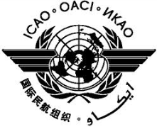 | International Civil Aviation Organization  Seventh Meeting of the Asia Pacific Regional Aviation Safety Team (APRAST/7)  (Bangkok, Thailand, 31 August to 4 September 2015)

Agenda Item X: | Xx

TITLE

(Presented by State/Organization)

SUMMARY

Text.

- INTRODUCTION

  - Text

  - Text

  - Text

- DISCUSSION

- Text

- Text

- Text

- ACTION BY THE MEETING

- The Meeting is invited to:

- Text;
- Text; and
- Text.

- Text.

— END —

